Feedback from Mocks:
- Please use the basic css scheme of Index.html with the Mets as chosen scheme team for the mock, but ensure you are using primary/secondary tags so that we can later check how it works for other color schemes,
- Game icons in the top strip to be touchable/clickable and if pressed they remove/add this games alerts from the active feed. There should be a visual but subtle marker that a game is enabled in the feed, and all games should be enabled by default.
- The matches top strip in the top Nav should stay the same height +- and if there are too many games should allow a left to right scroll (subtle scroll bar in theme with app, not the grey default scroll bar)
- Game that has progressed the most innings should be furthest left. A game in the bottom of inning x, should be considered going on longer than a game in top of inning x. if multiple games are in the exact same inning, can use alphabetical order to tiebreak.
- Upcoming games should appear in the games feed so if game starts during a session it can be chosen without a refresh or return to league pulse.
- Sounds Alerts: Home Run, RUN, RISP Situations, Game Start and Game end to all have there own unique sounds. We will later explore what sounds, for now just ensure that each event has a different sound and sound tag in code (if relevant).
- Events to make sounds on can be toggled on and off in a settings menu.
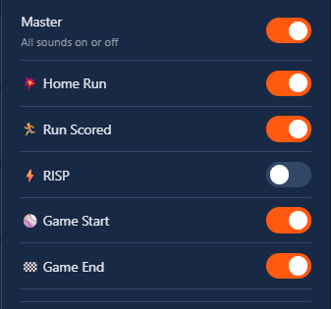
- This menu needs a smart location, and cant use the global settings from the upper Nav.
This placement will also be the way in future versions, we create player specific alerts (eventually don’t worry to much about this, just context to why I think this area needs its own setting.
- The RISP Icon that takes the row above the play, should be at the end of the play the same way place are displaying scores after runs.
- The score icon after the play for a run or a home run, should show in a subtle way, which side of the score just increased. Mock for 10 and 11 Below.
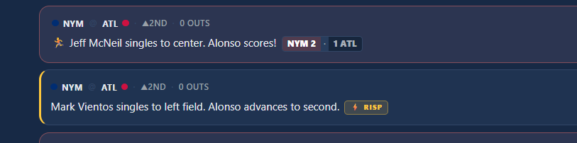
12) The screen of Market Pulse when there are no games playing, shouldn’t just be empty, we should say when the action will start. See mock below, but note in the mock the game cards are not great, we can make them more inline with the theming of the game cards from the home screen in index.html.
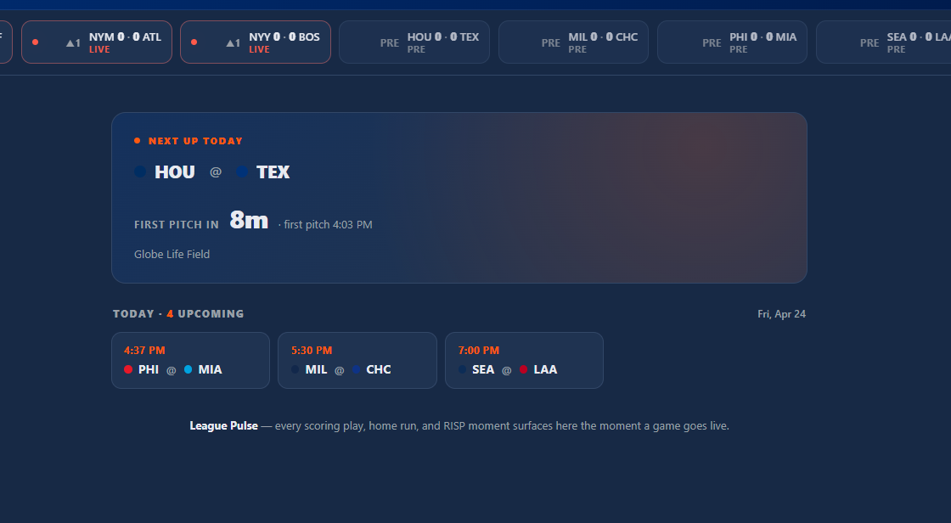
14) Find a solution for how I can attempt to verify this works during game time. I.E a version without Mock Data. I don’t mind if this is a toggle in the POC or a replica HTML. Defer to you on this, on what you think is the best approach. Please let me know in your response, how frequently I should expect the feature to check for a new event.

15) Create a file in the repo for backlogged items:
- Correct Sounds for each event.
  - Potentially - Sound theme packs — "broadcaster" (ESPN-style stingers), "retro arcade", "minimal" (just master tone).
- Claude Design Review / Improvements so theme is more inline with master application (index.html)
- Color Test with other teams schemas
- Leverage index — score-and-inning weighting (8th inning, 1-run game, bases loaded = 🔥 high-leverage chip glow).
- Player Related tracking Features
- Local setting support for sounds, and match enabled/disabled.

